# gwasExtra cookbook

gwasExtra is an R package or Shiny application specifically designed for Genome-Wide Association Studies (GWAS), aimed at providing additional functionalities and tools to assist researchers in processing, visualizing, and analyzing GWAS data.

**Home page**

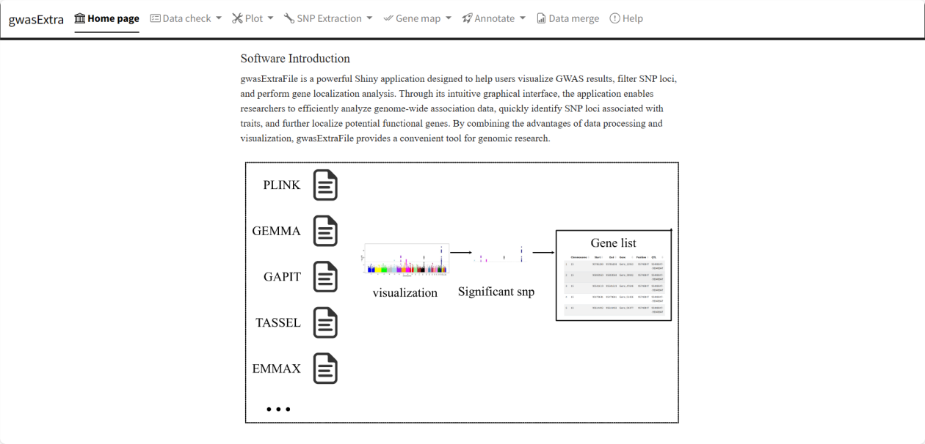

**Data check**

Demo data :

<https://github.com/w1996jy/gwasExtraFile/blob/main/data/pig60K.csv>

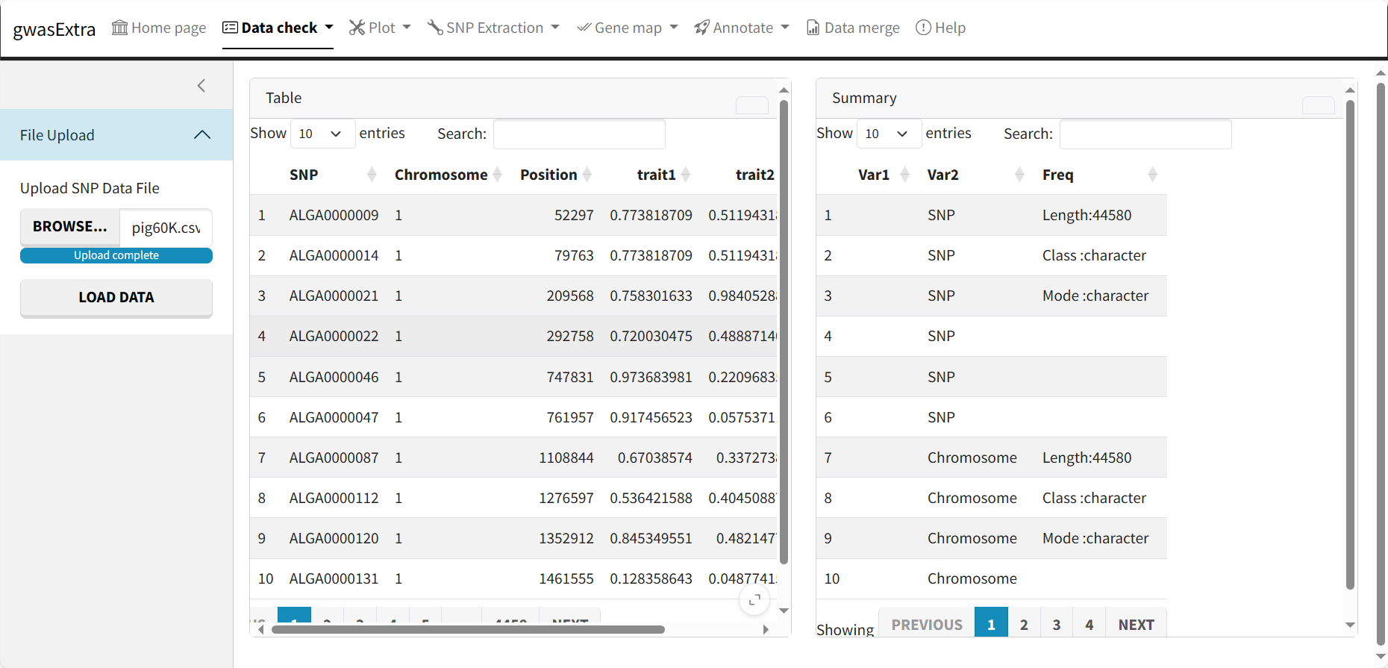

**GWAS result plot**

Demo data :

<https://github.com/w1996jy/gwasExtraFile/blob/main/data/pig60K.csv>

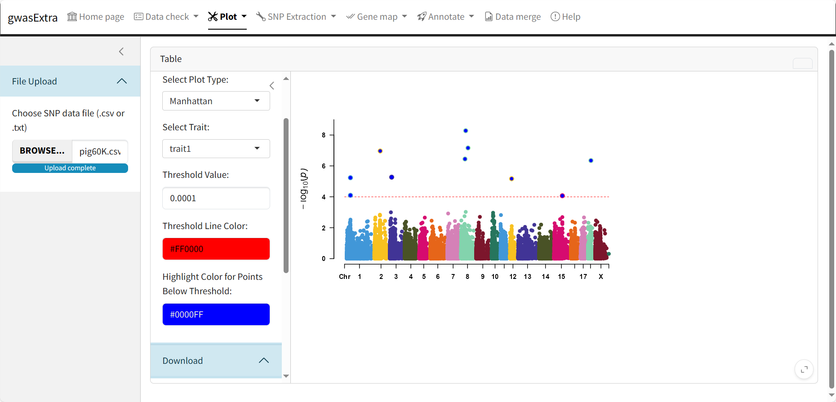

**SNP extract**

Demo data :

<https://github.com/w1996jy/gwasExtraFile/blob/main/data/pig60K.csv>

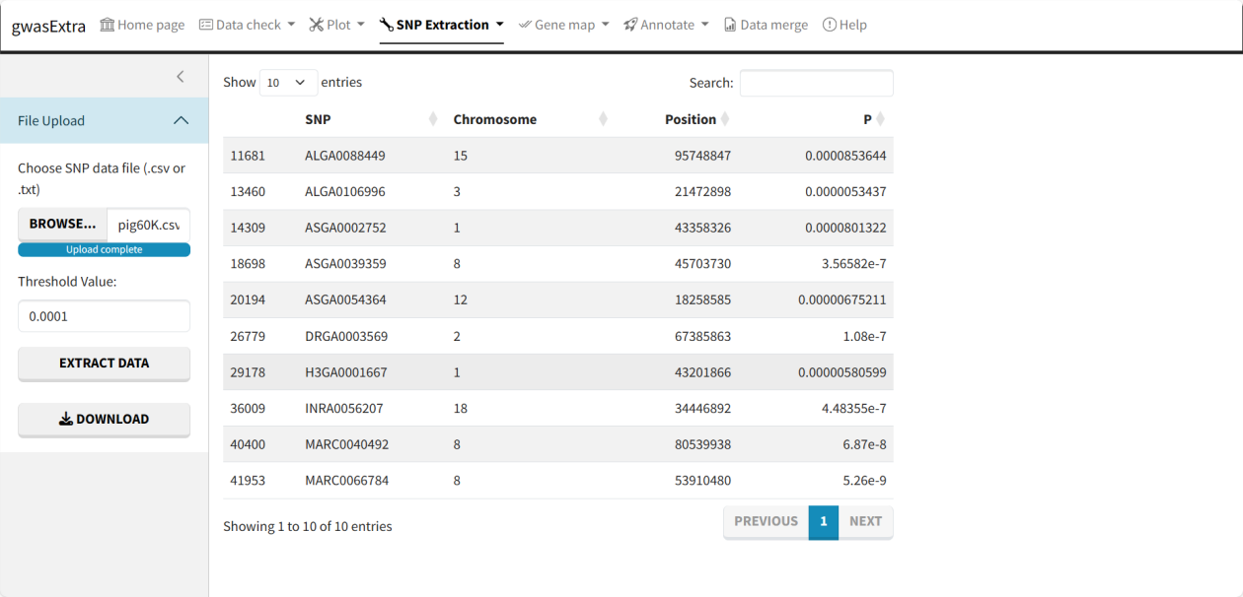

**Gene map**

Demo data :

<https://github.com/w1996jy/gwasExtraFile/blob/main/data/Significant_SNP.csv>

<https://github.com/w1996jy/gwasExtraFile/blob/main/data/gene_info.csv>

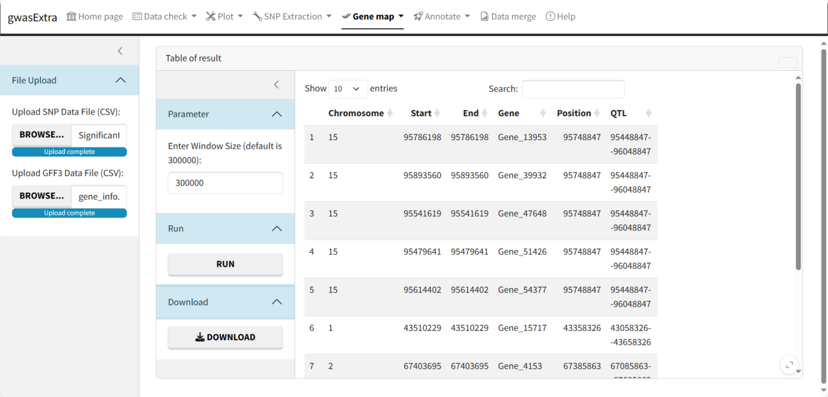

**Data merge**

Demo data :

<https://github.com/w1996jy/gwasExtraFile/blob/main/data/join_df1.xlsx>

<https://github.com/w1996jy/gwasExtraFile/blob/main/data/join_df2.xlsx>

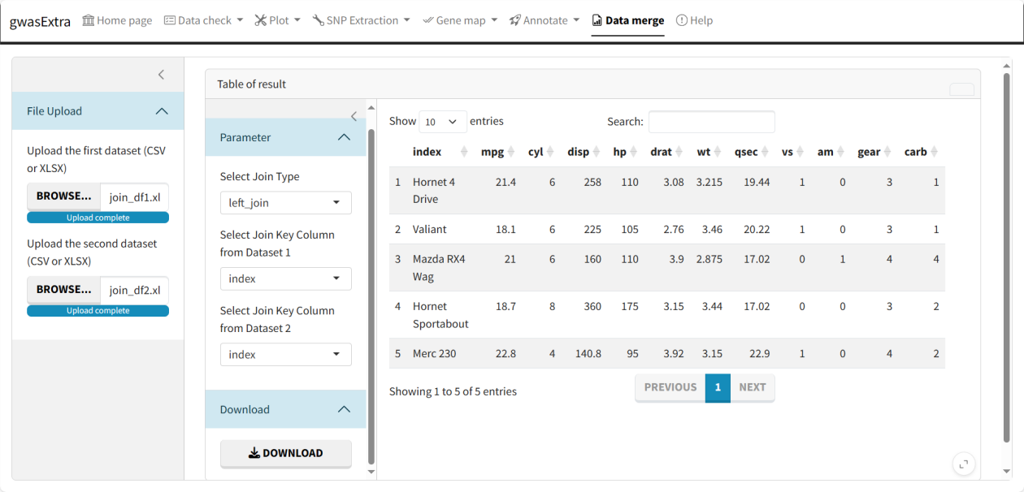

**contact**

If you need help while using the software, please contact me at Email: fyliangfei@163.com.